  Edna Extension  [Program Area] Extension Educator  [PHONE] |  [EMAIL]  Serving: Cornview, Plattelands, Thunderplains, & Sodbreaker Counties |   Extension Board Report  Fourth Quarter  Engaging with Nebraskans wherever they are, connecting them with the resources, research and innovation of the University of Nebraska.  Since last quarter we had…  - 430 youth attended a nutrition class  - 181 adults participated in a nutrition multi-class series  - 3 new partnerships formed with area agencies  - $45,000 in grant funds awarded to support ongoing programming in all four counties  4-H Health Rocks Mentoring Program  - We completed our 3rd year of offering the 4-H Health Rock program at Husker Grove Elementary School.  - The Health Rocks curriculum aims at helping youth develop skills necessary to make responsible decisions and to avoid participating in risky behaviors.  - About 45 mentees and 10 mentors met weekly at Seymour Elementary for the 4-H Health Rocks Mentoring program.  - Two of our key school partners of the program were recognized by Mentor Nebraska for their ongoing support and impact of our 4-H mentoring program.  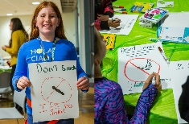  Commercial Pesticide Applicator Training  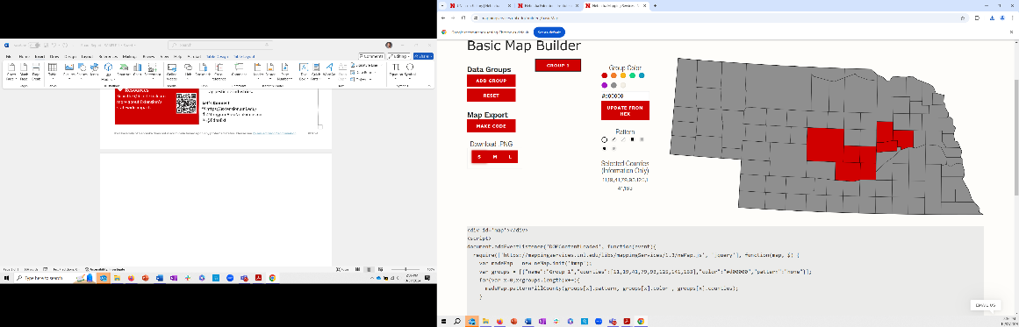  - Co-led 8 training classes focused on preparing professionals to take the commercial pesticide applicator license exam.  - 1,300 commercial applicators from 8 different counties attended representing lawncare, home pesticide, and ag pesticide industries.  Let’s Connect!  @ProgramAreaNebExtension  @EdnaExt
- Upcoming Extension Events
January
17 - Understanding Annual Cow Costs (Virtual)
23 – Mindfulness and Creativity for Childcare Workers (Husker Grove)

February
5 - Youth Science Day for Homeschooled Youth (Frontier Flats)

March
10 – Prepping for Spring Gardening (Virtual)
29 - Health Foods Fast (Cornvale)

- Partners
- Working with City of Huskers Chamber to support leadership program
- Collaborating with Parks & Rec coordinator to co-host out-of-school day programs over winter break
- Member of the Community Health Advisory committee

- Resources

Scan the QR code to learn more about Extension’s statewide impacts.

