
EXTENSION BOARD REPORT
[QUARTER OR REPORTING MONTHS]

Edna Extension
Let’s Connect!
@ProgramAreaNebExtension
@EdnaExt
[PROGRAM AREA] Extension Educator
[PHONE] | [EMAIL]
Cornview | Plattelands | Thunderplains | Sodbreaker
Engaging with Nebraskans wherever they are, connecting them with the resources, research and innovation of the University of Nebraska.  Program Data  Upcoming Extension Events  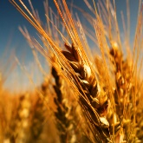  Grain Marketing Workshop  Nov. 21, 2024, 5:30 pm – 7:00 pm MST  Berea Lutheran Church, 2874 Hwy 27, Chappell, NE  Do you ever wonder what analysts are really saying about the grain markets?  The program is free to attend. Pre-registration is encouraged. To register call the Garden County Extension Office at 308-772-3311.  Resources  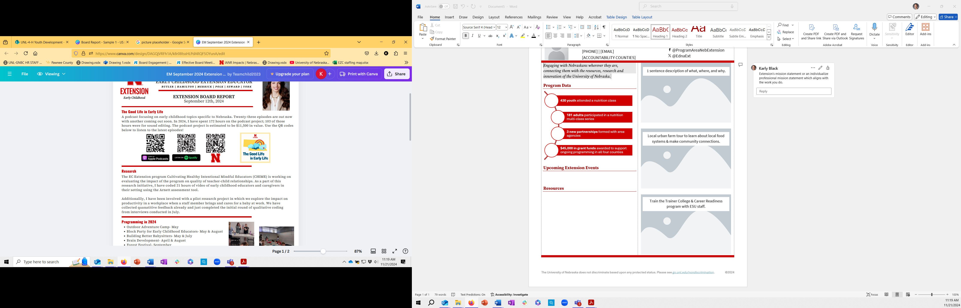 |   1 sentence description of what, where, and why.  Local urban farm tour to learn about local food systems & make community connections.  Train the Trainer College & Career Readiness program with ESU staff.

