Title II Accessible Social Media Examples

Example 1: 4-H Curriculum
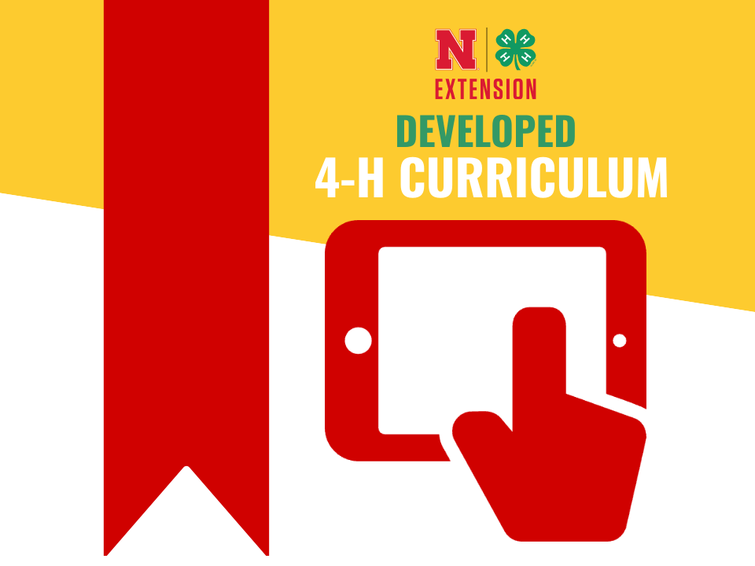
Alt Text: A red bookmark hangs on the left side. The Nebraska Extension and 4-H logo sits above 'Developed Curriculum'. A hand tapping a tablet illustrates digital access capabilities.
Caption: "🔎 Here's another reason to celebrate 4-H Member Month in Nebraska! New for this year, enrolled 4-H youth will receive complimentary access to 4-H curriculum developed at the University of Nebraska-Lincoln! 📖
These hands-on resources help youth explore their sparks further and cover a wide range of interests, including shopping, entomology, poultry, clothing, babysitting, and much more! To learn more about complementary 4-H Curriculum, read this article: https://4h.unl.edu/news/complimentary-4-h-curriculum-now-available-enrolled-nebraska-4-h-youth-and-volunteers/ #NE4HMemberMonth #Nebraska4H #BeyondReady"

Example 2: Beef Feedlot Roundtable Promotion
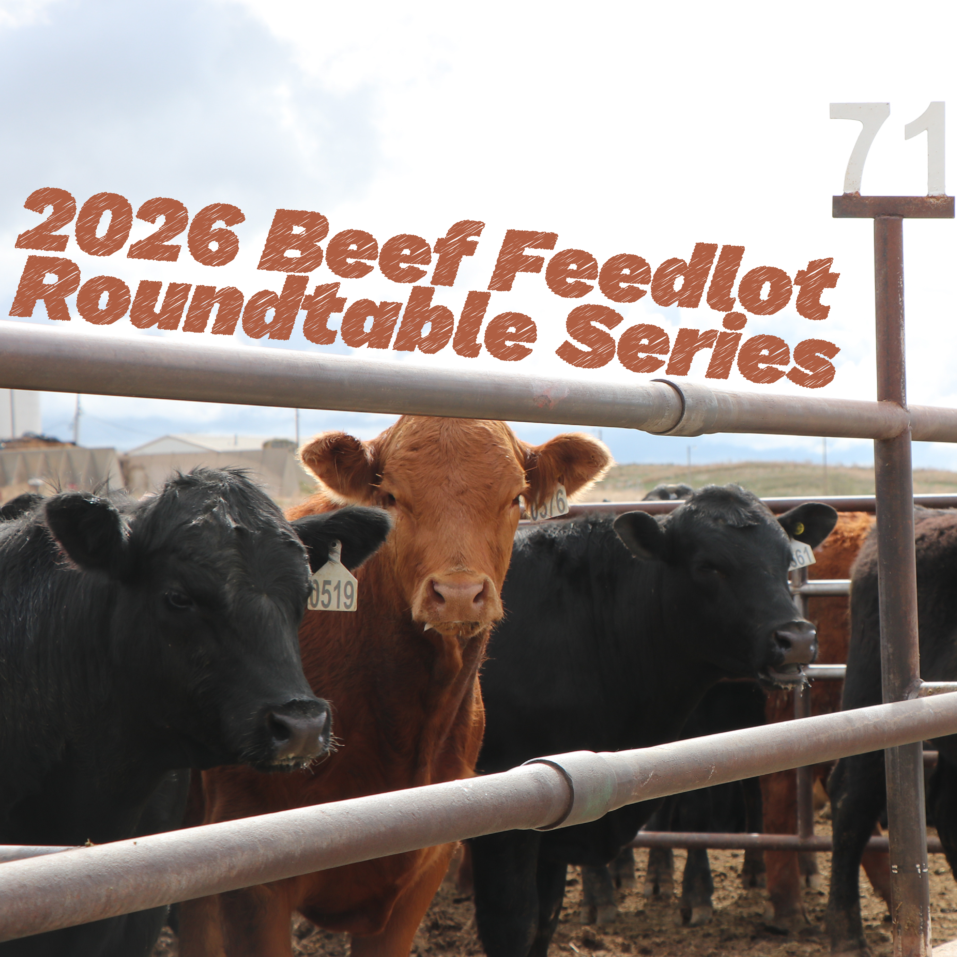
Alt Text: Red and black cattle look out from a fence in a feedlot. Text above them says '2026 Beef Feedlot Roundtable Series'.
Caption: "Feedlot owners, managers, employees, and industry professionals — you're invited to the 2026 Beef Feedlot Roundtable Series. The roundtable will be held on Tuesday, Feb. 17, from 10 am to 3 pm at the Prairie Winds Community Center in Bridgeport.
The Beef Feedlot Roundtable Series will feature timely, research-based discussions on feedlot management, cattle health, nutrition, and market outlooks — providing information attendees can directly apply to their operations.
Lunch is provided, and the cost to attend is $20 (payable at the door). If interested, pre-register at https://go.unl.edu/2026roundtable

Example 3: National Lamb Month
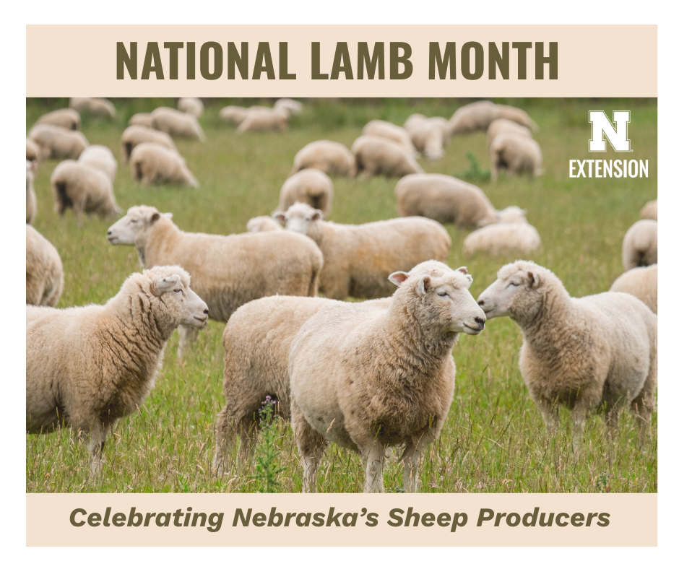
Alt Text: In a field of green grass stretching toward the horizon, a herd of sheep grazes peacefully. Text above and below reads 'National Lamb Month. Celebrating Nebraska's sheep producers’.
Caption: "February is National Lamb Month — a great time to recognize the hard‑working sheep producers across Nebraska! 🐑 Nebraska Extension offers valuable resources to support sheep producers year-round: https://animalscience.unl.edu/.../sheep-and-goat-extension/"

